# Viruses and the tree of life (<https://www.nature.com/scitable/content/viruses-and-the-tree-of-life-14465158/>)

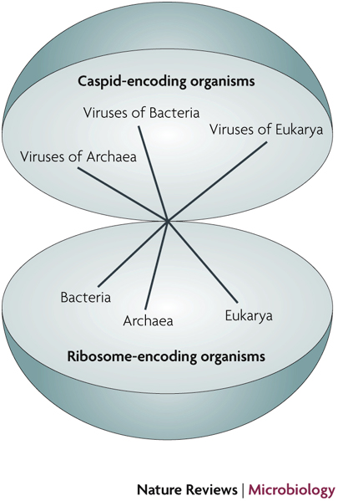

**Viruses and the tree of life**

Although most biologists would argue that viruses are not alive, some argue that viruses should be included in the tree of life. All organisms, they contend, should be divided into ribosome-encoding organisms (REOs) and capsid-encoding organisms (CEOs). Bacteria, archaea, and eukaryotes are REOs; viruses are CEOs.

**Eukaryotes** ([/juːˈkærioʊt, -ət/](https://en.wikipedia.org/wiki/Help:IPA/English)) are [organisms](https://en.wikipedia.org/wiki/Organism) whose cells have a [nucleus](https://en.wikipedia.org/wiki/Cell_nucleus) enclosed within [membranes](https://en.wikipedia.org/wiki/Biological_membrane), unlike [prokaryotes](https://en.wikipedia.org/wiki/Prokaryote) ([Bacteria](https://en.wikipedia.org/wiki/Bacteria) and [Archaea](https://en.wikipedia.org/wiki/Archaea)), which have no membrane-bound [organelles](https://en.wikipedia.org/wiki/Organelle).[[3]](https://en.wikipedia.org/wiki/Eukaryote#cite_note-Youngson-3)[[4]](https://en.wikipedia.org/wiki/Eukaryote#cite_note-Nelson&Cox-4)[[5]](https://en.wikipedia.org/wiki/Eukaryote#cite_note-Martin-5) Eukaryotes belong to the [domain](https://en.wikipedia.org/wiki/Domain_(biology)) **Eukaryota** or **Eukarya**. Their name comes from the [Greek](https://en.wikipedia.org/wiki/Greek_language) [εὖ](https://en.wiktionary.org/wiki/%CE%B5%E1%BD%96) (*eu*, "well" or "true") and [κάρυον](https://en.wiktionary.org/wiki/%CE%BA%CE%AC%CF%81%CF%85%CE%BF%CE%BD) (*karyon*, "nut" or "kernel").[[6]](https://en.wikipedia.org/wiki/Eukaryote#cite_note-OnlineEtDict-6) Eukaryotic cells typically contain other membrane-bound organelles such as [mitochondria](https://en.wikipedia.org/wiki/Mitochondrion) and the [Golgi apparatus](https://en.wikipedia.org/wiki/Golgi_apparatus), and in addition, some cells of [plants](https://en.wikipedia.org/wiki/Plant) and [algae](https://en.wikipedia.org/wiki/Algae) contain [chloroplasts](https://en.wikipedia.org/wiki/Chloroplast). Unlike [unicellular](https://en.wikipedia.org/wiki/Unicellular_organism) archaea and bacteria, eukaryotes may also be [multicellular](https://en.wikipedia.org/wiki/Multicellular_organism) and include organisms consisting of many [cell types](https://en.wikipedia.org/wiki/Cell_type) forming different kinds of [tissue](https://en.wikipedia.org/wiki/Tissue_(biology)). [Animals](https://en.wikipedia.org/wiki/Animal) and plants are the most familiar eukaryotes.

Eukaryotes can reproduce both [asexually](https://en.wikipedia.org/wiki/Asexual_reproduction) through [mitosis](https://en.wikipedia.org/wiki/Mitosis) and sexually through [meiosis](https://en.wikipedia.org/wiki/Meiosis) and [gamete](https://en.wikipedia.org/wiki/Gamete) fusion. In mitosis, one cell divides to produce two genetically identical cells. In meiosis, [DNA replication](https://en.wikipedia.org/wiki/DNA_replication) is followed by two rounds of [cell division](https://en.wikipedia.org/wiki/Cell_division) to produce four [haploid](https://en.wikipedia.org/wiki/Ploidy) daughter cells. These act as sex cells (gametes). Each gamete has just one set of chromosomes, each a unique mix of the corresponding pair of parental [chromosomes](https://en.wikipedia.org/wiki/Chromosome) resulting from [genetic recombination](https://en.wikipedia.org/wiki/Genetic_recombination) during meiosis.[[7]](https://en.wikipedia.org/wiki/Eukaryote#cite_note-7)

The domain Eukaryota is [monophyletic](https://en.wikipedia.org/wiki/Monophyly) and makes up one of the domains of life in the [three-domain system](https://en.wikipedia.org/wiki/Three-domain_system). The two other domains, Bacteria and Archaea, are [prokaryotes](https://en.wikipedia.org/wiki/Prokaryote)[[8]](https://en.wikipedia.org/wiki/Eukaryote#cite_note-nyt_2016_apr_11-8) and have none of the above features. Eukaryotes represent a tiny minority of all living things.[[9]](https://en.wikipedia.org/wiki/Eukaryote#cite_note-Whitman_etal-9) However, due to their generally much larger size, their collective worldwide [biomass](https://en.wikipedia.org/wiki/Biomass_(ecology)) is estimated to be about equal to that of prokaryotes.[[9]](https://en.wikipedia.org/wiki/Eukaryote#cite_note-Whitman_etal-9) Eukaryotes evolved approximately 1.6–2.1 billion years ago, during the [Proterozoic](https://en.wikipedia.org/wiki/Proterozoic) eon. (Wikpedia)

# The not so universal tree of life or the place of viruses in the living world.(Brüssow, 2009)

Darwin provided a great unifying theory for biology; its visual expression is the universal tree of life. The tree concept is challenged by the occurrence of horizontal gene transfer and—as summarized in this review—by the omission of viruses. Microbial ecologists have demonstrated that viruses are the most numerous biological entities on earth, outnumbering cells by a factor of 10. Viral genomics have revealed an unexpected size and distinctness of the viral DNA sequence space. Comparative genomics has shown elements of vertical evolution in some groups of viruses. Furthermore, structural biology has demonstrated links between viruses infecting the three domains of life pointing to a very ancient origin of viruses. However, presently viruses do not find a place on the universal tree of life, which is thus only a tree of cellular life. In view of the polythetic nature of current life definitions, viruses cannot be dismissed as non-living material. On earth we have therefore at least two large DNA sequence spaces, one represented by capsid-encoding viruses and another by ribosome-encoding cells. Despite their probable distinct evolutionary origin, both spheres were and are connected by intensive two-way gene transfers.

However, one important thing has not changed, the basic belief that all organisms, big or small, will most likely find their place on a universal network of life. In current thinking, all forms of life are derived from LUCA, the ‘last universal common ancestor’ of life (Woese 1998). The unifying concept of biology is thus surprisingly vigorous. Who would have believed that in Linné's time when individual species were still considered the result of unique acts of divine creation?

Interestingly, the only non-verbal information in Darwin's book was a single figure with a hypothetical tree of descent for organisms. In the late nineteenth century, Ernst Haeckel quickly popularized the tree by putting names on the branches. Darwin's tree has been grown into a veritable forest. From the very concept Darwin's tree was daring: not only extant, but also all extinct organisms found, in principle, a place on this tree. It was from the very beginning designed as a universal tree.

# Reasons to include viruses in the tree of life.(Hegde, Maddur, Kaveri, & Bayry, 2009)

We read with interest the recent article in Nature Reviews Microbiology by Moreira and López-García (Ten reasons to exclude viruses from the tree of life. Nature Rev. Microbiol. 7, 306–311 (2009))1 who courageously attempted to exclude viruses from the tree of life. The inability of viruses to self-sustain and self-replicate, their phylogenetic diversity, the origin of their cell-like genes and the instability of their genomes over time were emphasized to strengthen the argument. However, as discussed in this Correspondence, we emphasize that although we might be able to call viruses 'pseudo living entities' or 'molecular parasites' we cannot deprive them of their status as living entities.

# Coronavirus as a possible cause of severe acute respiratory syndrome(Peiris et al., 2003)

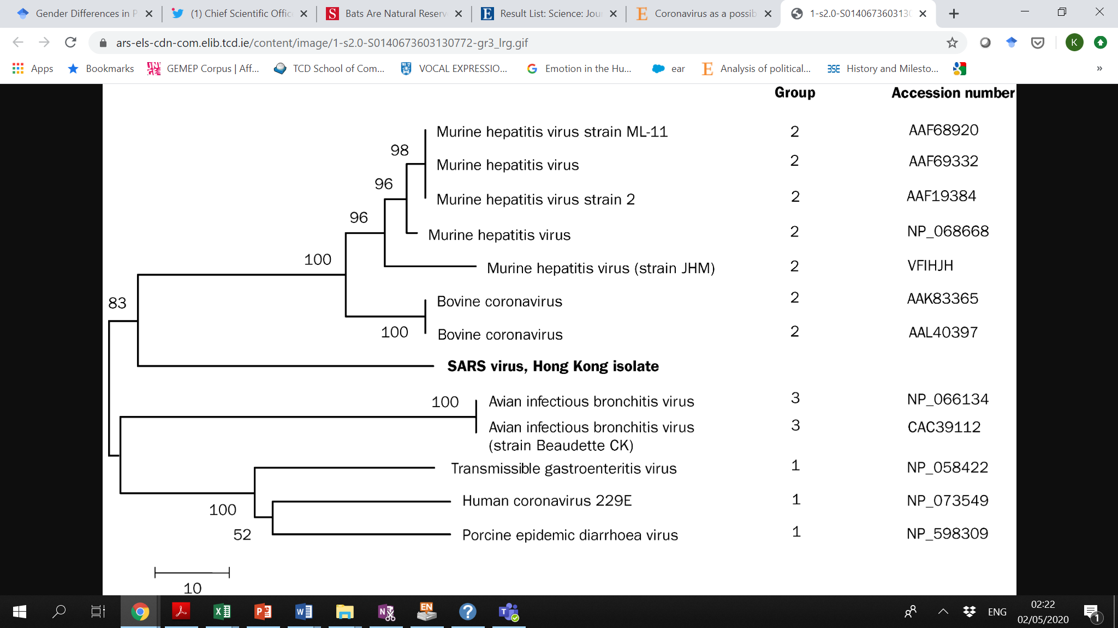

Figure 3. [Phylogenetic analysis](https://www-sciencedirect-com.elib.tcd.ie/topics/medicine-and-dentistry/phylogeny) of the partial [protein sequence](https://www-sciencedirect-com.elib.tcd.ie/topics/medicine-and-dentistry/peptide-sequence) (215 aminoacids) of the coronavirus (SARS)

# Genomic characterisation and epidemiology of 2019 novel coronavirus: implications for virus origins and receptor binding (Lu et al., 2020)

Findings The ten genome sequences of 2019-nCoV obtained from the nine patients were extremely similar, exhibiting more than 99·98% sequence identity. Notably, 2019-nCoV was closely related (with 88% identity) to two bat-derived severe acute respiratory syndrome (SARS)-like coronaviruses, bat-SL-CoVZC45 and bat-SL-CoVZXC21, collected in 2018 in Zhoushan, eastern China, but were more distant from SARS-CoV (about 79%) and MERS-CoV (about 50%). Phylogenetic analysis revealed that 2019-nCoV fell within the subgenus Sarbecovirus of the genus Betacoronavirus, with a relatively long branch length to its closest relatives bat-SL-CoVZC45 and bat-SL-CoVZXC21, and was genetically distinct from SARS-CoV. Notably, homology modelling revealed that 2019-nCoV had a similar receptor-binding domain structure to that of SARS-CoV, despite amino acid variation at some key residues.

***My inference***

|  |  |  |  |
| --- | --- | --- | --- |
| ***10 genome sequences*** | ***9 patients with 9 patients 2019- n-CoV*** | ***99.98% identity*** | ***2 bat-derived SARS (bat- SL-CoVZC45, and bat-SL-CoVZXC21)[[1]](#footnote-1) (88% identity)*** |
|  |  |  | ***distant from SARS-CoV (about 79%); MERS-CoV (about 50%)*** |

***2019 nCov genus Betacoronavirus subgenus Sarbecovirus***

# CRISPR–Cas12-based detection of SARS-CoV-2(Broughton et al., 2020)

An outbreak of betacoronavirus severe acute respiratory syndrome (SARS)-CoV-2 began in Wuhan, China in December 2019. COVID-19, the disease associated with SARS-CoV-2 infection, rapidly spread to produce a global pandemic. We report development of a rapid (<40 min), easy-to-implement and accurate CRISPR–Cas12-based lateral flow assay for detection of SARS-CoV-2 from respiratory swab RNA extracts. We validated our method using contrived reference samples and clinical samples from patients in the United States, including 36 patients with COVID-19 infection and 42 patients with other viral respiratory infections. Our CRISPR-based DETECTR assay provides a visual and faster alternative to the US Centers for Disease Control and Prevention SARS-CoV-2 real-time RT–PCR assay, with 95% positive predictive agreement and 100% negative predictive agreement.

My inference

***Outbreak betacoronavirus severe acute respiratory syndrome (SARS)-CoV-2 Wuhan, Dec 219***

***COVID-19, the disease associated with SARS-CoV-2 infection***

# Clinical characteristics of coronavirus disease 2019 in China (Guan et al., 2020)

In early December 2019, the first pneumonia cases of unknown origin were identified in Wuhan, the capital city of Hubei province.1 The pathogen has been identified as a novel enveloped RNA betacoronavirus2 that has currently been named severe acute respiratory syndrome coronavirus 2 (SARS-CoV-2), which has a phylogenetic similarity to SARS-CoV.3 Patients with the infection have been documented both in hospitals and in family settings.

clinical characteristics of Covid-19 mimic those of SARS-CoV. Fever and cough were the dominant symptoms and gastrointestinal symptoms were uncommon, which suggests a difference in viral tropism as compared with SARS-CoV, MERS-CoV, and seasonal influenza.

***My inference***

***Dec 2019 First pneumonia cases of unknown origin were identified in Wuhan***

***The pathogen?*** novel enveloped RNA betacoronavirus ***CURRENTLY named*** severe acute respiratory syndrome coronavirus 2 ***that has similarities to*** SARS-CoV ***(COVID-19, the disease associated with SARS-CoV-2 infection (Broughton et al., 2020).***

**[based on the symptoms] a difference in viral tropism as compared with SARS-CoV, MERS-CoV, and seasonal influenza**.

# Severe acute respiratory syndrome-related coronavirus–The species and its viruses, a statement of the Coronavirus Study Group (Gorbalenya, 2020)

The present outbreak of lower respiratory tract infections, including respiratory distress syndrome, is the third spillover, in only two decades, of an animal coronavirus to humans resulting in a major epidemic. Here, the Coronavirus Study Group (CSG) of the International Committee on Taxonomy of Viruses, which is responsible for developing the official classification of viruses and taxa naming (taxonomy) of the Coronaviridae family, assessed the novelty of the human pathogen tentatively named 2019-nCoV. Based on phylogeny, taxonomy and established practice, the CSG formally recognizes this virus as a sister to severe acute respiratory syndrome coronaviruses (SARS-CoVs) of the species Severe acute respiratory syndrome-related coronavirus and designates it as severe acute respiratory syndrome coronavirus 2 (SARS-CoV-2). To facilitate communication, the CSG further proposes to use the following naming convention for individual isolates: SARS-CoV-2/Isolate/Host/Date/Location. The spectrum of clinical manifestations associated with SARS-CoV-2 infections in humans remains to be determined. The independent zoonotic transmission of SARS-CoV and SARS-CoV-2 highlights the need for studying the entire (virus) species to complement research focused on individual pathogenic viruses of immediate significance. This research will improve our understanding of virus-host interactions in an ever-changing environment and enhance our preparedness for future outbreaks.

The current classification of coronaviruses includes taxa at eight out of the fifteen available ranks15, and it recognizes forty-nine species in twenty-seven subgenera, five genera and two subfamilies that belong to the family Coronaviridae, suborder Cornidovirineae, order Nidovirales, realm Riboviria16-18. The family classification and taxa naming (taxonomy) are developed by the Coronavirus Study Group (CSG), a working group of the International Committee on Taxonomy of Viruses (ICTV)19. The CSG has responsibility in assessing the novelty of viruses through their relation to known viruses in established taxa and, for the purpose of this paper, specifically in the context of the species Severe acute respiratory syndrome-related coronavirus.

***My inference***

recognizes forty-nine species in twenty-seven subgenera, five genera and two subfamilies that belong to the family Coronaviridae, suborder Cornidovirineae, order Nidovirales, realm Riboviria16-18.

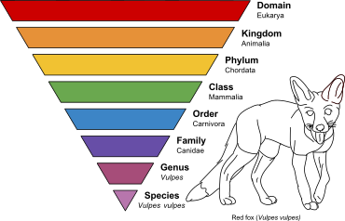***(Wikpedia 🡪 Taxonomic Rank*)**

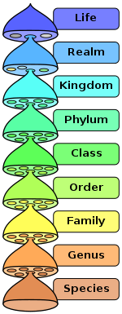 The hierarchy of [biological classification](https://en.wikipedia.org/wiki/Biological_classification)'s eight major taxonomic ranks. Intermediate minor rankings are not shown.

|  |  |  |  |  |  |  |
| --- | --- | --- | --- | --- | --- | --- |
| **Rank** | [**Bacteria**](https://en.wikipedia.org/wiki/Bacteria)[[10]](https://en.wikipedia.org/wiki/Taxonomic_rank#cite_note-Euz%C3%A9by1997-11) | [**Plants**](https://en.wikipedia.org/wiki/Plant) | [**Algae**](https://en.wikipedia.org/wiki/Algae) | [**Fungi**](https://en.wikipedia.org/wiki/Fungus) | [**Animals**](https://en.wikipedia.org/wiki/Animal) | [**Viruses**](https://en.wikipedia.org/wiki/Virus)[[11]](https://en.wikipedia.org/wiki/Taxonomic_rank#cite_note-ICTV_2018-12) |
| **Division/Phylum** |  | -phyta [/ˈfaɪtə/](https://en.wikipedia.org/wiki/Help:IPA/English) | -phyta[[12]](https://en.wikipedia.org/wiki/Taxonomic_rank" \l "cite_note-Shenzhen_Code-13) [/ˈfaɪtə/](https://en.wikipedia.org/wiki/Help:IPA/English) | -mycota [/maɪˈkoʊtə/](https://en.wikipedia.org/wiki/Help:IPA/English) |  | -viricota [/vaɪrɪˈkoʊtə/](https://en.wikipedia.org/wiki/Help:IPA/English) |
| **Subdivision/Subphylum** |  | -phytina [/fɪˈtaɪnə/](https://en.wikipedia.org/wiki/Help:IPA/English) | -phytina[[12]](https://en.wikipedia.org/wiki/Taxonomic_rank" \l "cite_note-Shenzhen_Code-13) [/fɪˈtaɪnə/](https://en.wikipedia.org/wiki/Help:IPA/English) | -mycotina [/maɪkoʊˈtaɪnə/](https://en.wikipedia.org/wiki/Help:IPA/English) |  | -viricotina [/vaɪrɪkoʊˈtaɪnə/](https://en.wikipedia.org/wiki/Help:IPA/English) |
| **Class** | -ia [/iə/](https://en.wikipedia.org/wiki/Help:IPA/English) | -opsida [/ˈɒpsɪdə/](https://en.wikipedia.org/wiki/Help:IPA/English) | -phyceae [/ˈfaɪʃi/](https://en.wikipedia.org/wiki/Help:IPA/English) | -mycetes [/maɪˈsiːtiːz/](https://en.wikipedia.org/wiki/Help:IPA/English) |  | -viricetes [/vaɪrɪˈsiːtiːz/](https://en.wikipedia.org/wiki/Help:IPA/English) |
| **Subclass** | -idae [/ɪdi/](https://en.wikipedia.org/wiki/Help:IPA/English) | | -phycidae [/ˈfɪsɪdi/](https://en.wikipedia.org/wiki/Help:IPA/English) | -mycetidae [/maɪˈsɛtɪdi/](https://en.wikipedia.org/wiki/Help:IPA/English) |  | -viricetidae [/vaɪrɪˈsɛtɪdi/](https://en.wikipedia.org/wiki/Help:IPA/English) |
| **Superorder** |  | -anae [/ˈeɪni/](https://en.wikipedia.org/wiki/Help:IPA/English) | | |  |  |
| **Order** | -ales [/ˈeɪliːz/](https://en.wikipedia.org/wiki/Help:IPA/English) | | | |  | -virales [/vaɪrˈeɪliːz/](https://en.wikipedia.org/wiki/Help:IPA/English) |
| **Suborder** | -ineae [/ˈɪnii/](https://en.wikipedia.org/wiki/Help:IPA/English) | | | |  | -virineae [/vaɪrˈɪnii/](https://en.wikipedia.org/wiki/Help:IPA/English) |
| **Infraorder** |  | -aria [/ˈɛəriə/](https://en.wikipedia.org/wiki/Help:IPA/English) | | |  |  |
| **Superfamily** |  | -acea [/ˈeɪʃə/](https://en.wikipedia.org/wiki/Help:IPA/English) | | | -oidea [/ˈɔɪdiə/](https://en.wikipedia.org/wiki/Help:IPA/English) |  |
| **Epifamily** |  |  |  |  | -oidae [/ˈɔɪdi/](https://en.wikipedia.org/wiki/Help:IPA/English) |  |
| **Family** | -aceae [/ˈeɪʃi/](https://en.wikipedia.org/wiki/Help:IPA/English) | | | | -idae [/ɪdi/](https://en.wikipedia.org/wiki/Help:IPA/English) | -viridae [/vaɪrˈɪdi/](https://en.wikipedia.org/wiki/Help:IPA/English) |
| **Subfamily** | -oideae [/ˈɔɪdii/](https://en.wikipedia.org/wiki/Help:IPA/English) | | | | -inae [/ˈaɪni/](https://en.wikipedia.org/wiki/Help:IPA/English) | -virineae [/vaɪrˈɪni/](https://en.wikipedia.org/wiki/Help:IPA/English) |
| **Infrafamily** |  |  |  |  | -odd [/ɒd/](https://en.wikipedia.org/wiki/Help:IPA/English)[[13]](https://en.wikipedia.org/wiki/Taxonomic_rank#cite_note-14) |  |
| **Tribe** | -eae [/ii/](https://en.wikipedia.org/wiki/Help:IPA/English) | | | | -ini [/ˈaɪnaɪ/](https://en.wikipedia.org/wiki/Help:IPA/English) |  |
| **Subtribe** | -inae [/ˈaɪni/](https://en.wikipedia.org/wiki/Help:IPA/English) | | | | -ina [/ˈaɪnə/](https://en.wikipedia.org/wiki/Help:IPA/English) |  |
| **Infratribe** |  |  |  |  | -ad [/æd/](https://en.wikipedia.org/wiki/Help:IPA/English) or -iti [/ˈaɪti/](https://en.wikipedia.org/wiki/Help:IPA/English) |  |

# References

Broughton, J. P., Deng, X., Yu, G., Fasching, C. L., Servellita, V., Singh, J., . . . Sotomayor-Gonzalez, A. (2020). CRISPR–Cas12-based detection of SARS-CoV-2. *Nature Biotechnology*, 1-5.

Brüssow, H. (2009). The not so universal tree of life or the place of viruses in the living world. *Philosophical Transactions of the Royal Society B: Biological Sciences, 364*(1527), 2263-2274.

Gorbalenya, A. E. (2020). Severe acute respiratory syndrome-related coronavirus–The species and its viruses, a statement of the Coronavirus Study Group. *BioRxiv*.

Guan, W.-j., Ni, Z.-y., Hu, Y., Liang, W.-h., Ou, C.-q., He, J.-x., . . . Hui, D. S. (2020). Clinical characteristics of coronavirus disease 2019 in China. *New England Journal of Medicine, 382*(18), 1708-1720.

Hegde, N. R., Maddur, M. S., Kaveri, S. V., & Bayry, J. (2009). Reasons to include viruses in the tree of life. *Nature Reviews Microbiology, 7*(8), 615-615.

Lu, R., Zhao, X., Li, J., Niu, P., Yang, B., Wu, H., . . . Zhu, N. (2020). Genomic characterisation and epidemiology of 2019 novel coronavirus: implications for virus origins and receptor binding. *The Lancet, 395*(10224), 565-574.

Peiris, J., Lai, S., Poon, L., Guan, Y., Yam, L., Lim, W., . . . Cheung, M. (2003). Coronavirus as a possible cause of severe acute respiratory syndrome. *The Lancet, 361*(9366), 1319-1325.

1. collected inZhoushan, eastern China [↑](#footnote-ref-1)